**Московский государственный технический университет им. Н.Э. Баумана**

**Министерство науки и высшего образования Российской Федерации Федеральное государственное бюджетное образовательное учреждение высшего образования**

**«Московский государственный технический университет имени Н.Э. Баумана**

**(национальный исследовательский университет)»**

**(МГТУ им. Н.Э. Баумана)**

Курс «Разработка интернет-приложений»

Отчет по лабораторной работе №4

Выполнил:

студент группы ИУ5Ц-72Б Гусев С.Р.

Преподаватель:

Гапанюк Ю.Е

2020

1. Описание задания
2. Необходимо для произвольной предметной области реализовать три шаблона проектирования: один порождающий, один структурный и один поведенческий. В качестве справочника шаблонов можно использовать [следующий каталог.](https://refactoring.guru/ru/design-patterns/facade)
3. Для каждой реализации шаблона необходимо написать модульный тест. В модульных тестах необходимо применить следующие технологии:
   * TDD - фреймворк.
   * BDD - фреймворк.
4. Текст программы
5. **Фасад шаблон проектирования (Facade.py)**

В качестве порождающего шаблона используется паттерн фасад -это структурный паттерн проектирования, который предоставляет простой интерфейс к сложной системе классов, библиотеке или фреймворку. В данной задаче приведен пример применения этого паттерна к предметной области «Магазин».

Текст программы:

from __future__ import annotations

from lab_python_pt.factory.ShopFactory import SportShopFactory, ElectronicsShopFactory, get_shop

from lab_python_pt.factory.ClientFactory import SportShopClientFactory, ElectronicsShopClientFactory, \

SportElectronicsShopClientFactory, get_client

class Facade:

""" В зависимости от потребностей вашего приложения вы можете предоставить

Фасаду существующие объекты подсистемы или заставить Фасад создать их

самостоятельно.

"""

def __init__(self, sport_shops=None,

electronics_shops=None,

sport_shop_clients=None,

electronics_shop_clients=None,

sport_electronics_shop_clients=None):

if sport_electronics_shop_clients is None:

sport_electronics_shop_clients = []

if electronics_shop_clients is None:

electronics_shop_clients = []

if sport_shop_clients is None:

sport_shop_clients = []

if electronics_shops is None:

electronics_shops = []

if sport_shops is None:

sport_shops = []

self.__sport_shops = sport_shops

self.__electronics_shops = electronics_shops

self.__sport_shop_clients = sport_shop_clients

self.__electronics_shop_clients = electronics_shop_clients

self.__sport_electronics_shop_clients = sport_electronics_shop_clients

@property

def sport_shops(self):

return self.__sport_shops

@property

def electronics_shops(self):

return self.__electronics_shops

@property

def sport_shop_clients(self):

return self.__sport_shop_clients

@property

def electronics_shop_clients(self):

return self.__electronics_shop_clients

@property

def sport_electronics_shop_clients(self):

return self.__sport_electronics_shop_clients

def sport_shop_business_logic(self):

print('Бизнес-логика спортивного магазина:')

for i in range(0, len(self.__sport_shops)):

self.__sport_shops[i].business_logic()

print('\n')

def electronic_shop_business_logic(self):

print('Бизнес-логика магазина электроники:')

for i in range(0, len(self.__electronics_shops)):

self.__electronics_shops[i].business_logic()

print('\n')

def create_shops(self, sport_shop_count, electronics_shops_count):

print('Заводские магазины:')

self.__create_shops('спорт',

self.__sport_shops,

sport_shop_count,

SportShopFactory())

self.__create_shops('электроника',

self.__electronics_shops,

electronics_shops_count,

ElectronicsShopFactory())

print('\n')

def create_clients(self,

sport_shop_clients_count,

electronics_shop_clients_count,

sport_electronics_shop_clients_count):

print('\nЗаводской клиент:')

self.__create_clients('спорт',

self.__sport_shop_clients,

sport_shop_clients_count,

SportShopClientFactory())

self.__create_clients('элетроника',

self.__electronics_shop_clients,

electronics_shop_clients_count,

ElectronicsShopClientFactory())

self.__create_clients('спорт электроника',

self.__sport_electronics_shop_clients,

sport_electronics_shop_clients_count,

SportElectronicsShopClientFactory())

print('\n')

def attach_clients(self):

print('Прикрепление наблюдателя:')

self.__attach_clients('спорт',

self.__sport_shops,

self.__sport_shop_clients)

self.__attach_clients('электроника',

self.__electronics_shops,

self.__electronics_shop_clients)

self.__attach_clients('спорт электроника',

self.__sport_shops,

self.__sport_electronics_shop_clients)

self.__attach_clients('спорт электроника',

self.__electronics_shops,

self.__sport_electronics_shop_clients)

print('\n')

"""

Методы Фасада удобны для быстрого доступа к сложной функциональности

подсистем. Однако клиенты получают только часть возможностей подсистемы.

"""

def detach_clients(self):

print('Прикрепление наблюдателя:')

self.__detach_clients('спорт',

self.__sport_shops,

self.__sport_shop_clients)

self.__detach_clients('электроника',

self.__electronics_shops,

self.__electronics_shop_clients)

self.__detach_clients('электроника спорт',

self.__sport_shops,

self.__sport_electronics_shop_clients)

self.__detach_clients('спорт электроника',

self.__electronics_shops,

self.__sport_electronics_shop_clients)

print('\n')

def __create_shops(self, str, shops_list, count, factory):

print('\nСоздать {} {} магазины:'.format(count, str))

for i in range(0, count):

shops_list.append(get_shop(factory, i))

def __create_clients(self, str, clients_list, count, factory):

print('\nСоздать {} {} магазин клиенты:'.format(count, str))

for i in range(0, count):

clients_list.append(get_client(factory, i))

def __attach_clients(self, str, shop_list, clients_list):

print('\nПрикрепить {} {} магазин клиенты:'.format(len(clients_list), str))

for i in range(0, len(shop_list)):

for j in range(0, len(clients_list)):

shop_list[i].attach(clients_list[j])

def __detach_clients(self, str, shop_list, clients_list):

print('\nОткрепить {} {} магазин клиенты:'.format(len(clients_list), str))

for i in range(0, len(shop_list)):

for j in range(0, len(clients_list)):

shop_list[i].detach(clients_list[j])

Экранные формы:

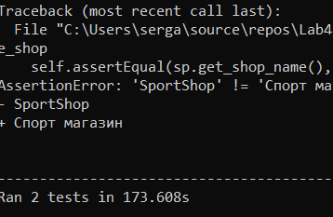

1. **ClientFactory.py and ShopFactory.py**

Текст программы:

from __future__ import annotations

from abc import ABC, abstractmethod

from lab_python_pt.observer.Observer import Clients, SportShopClient, ElectronicsShopClient, SportElectronicsShopClient

class ClientFactory(ABC):

_CLIENT_FACTORY_NAME = None

@abstractmethod

def factory_method(self, id):

pass

@property

def client_factory_name(self):

return self._CLIENT_FACTORY_NAME

class SportShopClientFactory(ClientFactory):

_CLIENT_FACTORY_NAME = 'SportShopClientFactory'

def factory_method(self, id) -> Clients:

print('{}: Создать нового клиента с id = {}'.format(self._CLIENT_FACTORY_NAME, id))

return SportShopClient(id)

class ElectronicsShopClientFactory(ClientFactory):

_CLIENT_FACTORY_NAME = 'ElectronicsShopClientFactory'

def factory_method(self, id) -> Clients:

print('{}: Создать нового клиента с id = {}'.format(self._CLIENT_FACTORY_NAME, id))

return ElectronicsShopClient(id)

class SportElectronicsShopClientFactory(ClientFactory):

_CLIENT_FACTORY_NAME = 'SportElectronicsShopClientFactory'

def factory_method(self, id) -> Clients:

print('{}: Создать нового клиента с id = {}'.format(self._CLIENT_FACTORY_NAME, id))

return SportElectronicsShopClient(id)

def get_client(factory: ClientFactory, id):

return factory.factory_method(id)

from __future__ import annotations

from abc import ABC, abstractmethod

from lab_python_pt.observer.Observer import Shops, SportShop, ElectronicsShop

class ShopFactory(ABC):

_SHOP_FACTORY_NAME = None

@abstractmethod

def factory_method(self, id):

pass

@property

def shop_factory_name(self):

return self._SHOP_FACTORY_NAME

class SportShopFactory(ShopFactory):

_SHOP_FACTORY_NAME = 'SportShopFactory'

def factory_method(self, id) -> Shops:

print('{}: Создать нового клиента с id = {}'.format(self._SHOP_FACTORY_NAME, id))

return SportShop(id)

class ElectronicsShopFactory(ShopFactory):

_SHOP_FACTORY_NAME = 'ElectronicsShopFactory'

def factory_method(self, id) -> Shops:

print('{}: Создать нового клиента id = {}'.format(self._SHOP_FACTORY_NAME, id))

return ElectronicsShop(id)

def get_shop(factory: ShopFactory, id):

return factory.factory_method(id)

Экранные формы:

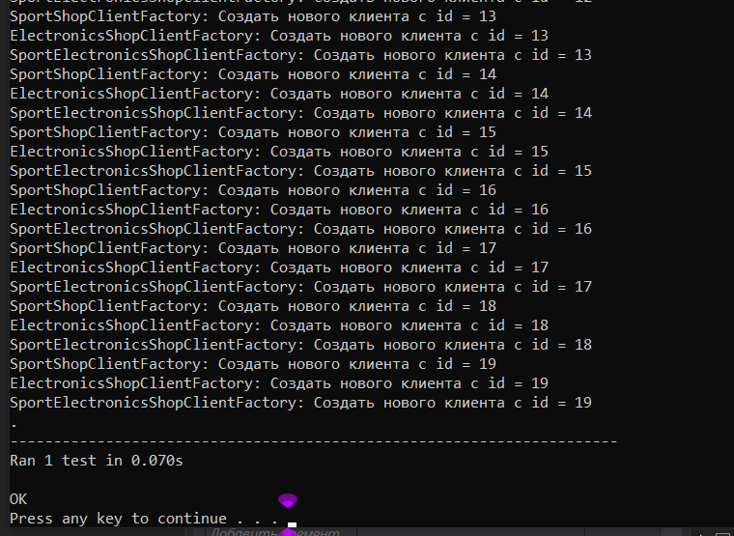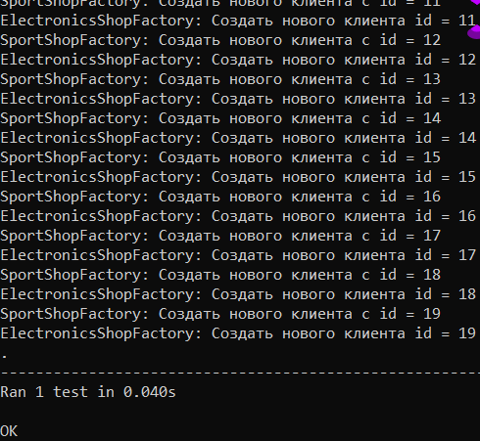

1. **Observe.py**

Текст программы:

from __future__ import annotations

from abc import ABC, abstractmethod

from random import randrange

from typing import List

class Shops(ABC):

_SHOP_NAME = None

def __init__(self, id, count=0):

self._id = id

self._count_new_items = count

self._clients: List[Clients] = []

@classmethod

def get_shop_name(cls):

return cls._SHOP_NAME

@property

def id(self):

return self._id

def attach(self, client: Clients) -> None:

print('{} {}: Attached an observer = {} {}'.format(self._SHOP_NAME, self._id, client.get_client_name(),

client.id))

self._clients.append(client)

def detach(self, client: Clients) -> None:

print('{} {}: Detached an observer = {} {}'.format(self._SHOP_NAME, self._id, client.get_client_name(),

client.id))

self._clients.remove(client)

def notify(self) -> None:

print('{} {}: {} observers'.format(self._SHOP_NAME, self._id, len(self._clients)))

if len(self._clients) != 0:

print('{} {}: Notifying observers...'.format(self._SHOP_NAME, self._id))

for client in self._clients:

client.update(self)

@abstractmethod

def business_logic(self) -> None:

pass

@property

def count_new_items(self):

return self._count_new_items

@property

def clients(self):

return self._clients

class SportShop(Shops):

_SHOP_NAME = 'SportShop'

def business_logic(self) -> None:

if self._count_new_items == 0:

self._count_new_items = randrange(0, 10)

print('\n{} {}: I received {} new items'.format(self._SHOP_NAME, self._id, self._count_new_items))

self.notify()

class ElectronicsShop(Shops):

_SHOP_NAME = 'ElectronicsShop'

def business_logic(self) -> None:

if self._count_new_items == 0:

self._count_new_items = randrange(0, 15)

print('\n{} {}: I received {} new items'.format(self._SHOP_NAME, self._id, self._count_new_items))

self.notify()

class Clients(ABC):

_CLIENT_NAME = None

def __init__(self, id):

self._id = id

self._go_to_shop = False

@classmethod

def get_client_name(cls):

return cls._CLIENT_NAME

@abstractmethod

def update(self, shop: Shops) -> None:

pass

@property

def id(self):

return self._id

@property

def go_to_shop(self):

return self._go_to_shop

class SportShopClient(Clients):

_CLIENT_NAME = 'SportShopClient'

def update(self, shop: Shops) -> None:

self._go_to_shop = False

if shop.count_new_items >= 5:

print('{} {}: Reacted to the event'.format(self._CLIENT_NAME, self._id))

self._go_to_shop = True

class ElectronicsShopClient(Clients):

_CLIENT_NAME = 'ElectronicsShopClient'

def update(self, shop: Shops) -> None:

self._go_to_shop = False

if shop.count_new_items >= 7:

print('{} {}: Reacted to the event'.format(self._CLIENT_NAME, self._id))

self._go_to_shop = True

class SportElectronicsShopClient(Clients):

_CLIENT_NAME = 'SportElectronicsShopClient'

def update(self, shop: Shops) -> None:

self._go_to_shop = False

if shop.count_new_items >= 5 and shop.get_shop_name() == 'SportShop':

print('{} {}: Reacted to the event'.format(self._CLIENT_NAME, self._id))

self._go_to_shop = True

if shop.count_new_items >= 7 and shop.get_shop_name() == 'ElectronicsShop':

print('{} {}: Reacted to the event'.format(self._CLIENT_NAME, self._id))

self._go_to_shop = True

Экранные формы:

